题型清单01 应用文写作之建议信、倡议书和演讲/发言稿
内容导览 知识·方法·能力清单
第一部分 命题解码 洞察命题意图，明确攻坚方向
第二部分 答题模板 构建思维框架，提炼解题技巧
解题思路 技法清单
考点01 建议信
考点02 倡议书
考点03 演讲/发言信
第三部分 思维引路 示范解题过程，贯通方法应用
链接高考 思维解析 变式应用
第四部分 分级实战 分级强化训练，实现能力跃迁

1. 建议信
建议信要求考生就某事向他人或组织提出自己的建议或忠告，希望对方接受自己的想法并解决相关问题。
2. 倡议书
倡议书是就某些事情或问题，向有关方面、部门或群体发出倡议、提出建议所使用的日常应用文；
其相当于单位、集体或个人公开倡导举办某项活动、开展某项工作，并希望能够得到广泛响应，有更多的人来支持和参与的应用文。它可以被张贴或邮寄给有关单位，也可以在报刊上发表。倡议书必须将语言建立在客观事实的基础上，讲究可信性和劝说性。
文体。
3. 演讲/发言稿
演讲/发言稿是在某些公共场合或较为隆重的仪式上围绕某一主题发表演讲的专用文稿，目的是把观点或主张等传达给听众。

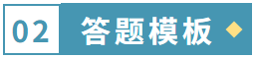
解题思路
段落 | 建议信 | 倡议书 | 演讲/发言稿
第一段 | 交代背景，表明意图 | 说明倡议的背景、目的或主题 | 说明演讲主题
第二段 | 提出具体建议，陈述理由 | 阐述倡议的具体内容或理由 | 就主题展开阐述或提出看法
第三段 | 表示欢迎或期待 | 提出呼吁或发出号召 | 进行总结或提出希望并表示感谢
技法清单
考点01 建议信
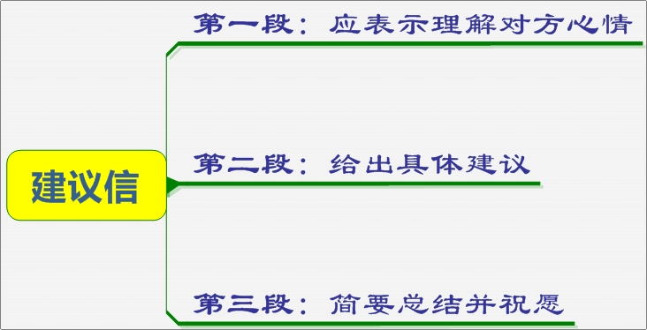
必识核心词汇
1. advice/tip/suggestion n. 建议
2. advise/suggest vt. 建议
3. beneficial adj. 有益的
4. benefit n.益处v. 受益于;使受益
5. following adj. 以下的
6. practical adj. 实用的
7. as far as sb. be concerned依某人看
8. ask for sb's advice 征求某人的建议
9. give/offer sb. advice/tips/suggestions on sth. 在某方面给某人提建议
10. have trouble/difficulty with sth. 在某方面有困难
11. have trouble/ difficulty (in) doing sth. 做某事有困难
12. have problems with sth. 在某方面有问题
13. in one's view/opinion 某人认为
14. make some suggestions/advice 提出一些建议
- accept/take/follow one's advice接受某人的建议

必记高级句式
【满分句型模板之开篇“凤头”句】
1. When it comes to/As for..., the following are my suggestions./My suggestions are as follows.
当涉及/关于……，我的建议如下。
2. I'm writing to give you some suggestions/give you a hand.
我写这封信的目的是给你一些建议/帮助。
3. I'm extremely delighted to receive your letter, in which you asked me how to fit in the new school life.
很高兴收到你的来信，信上询问我关于如何适应新的学校生活。
【满分句型模板之中间“猪肚”句】
1. I recommend it mainly for the following two reasons.
我推荐它主要有以下两个原因。
2. As far as I'm concerned/Personally, it would be wise to take the following action.
在我看来，采取如下行动是明智的。
3. I think it would be of benefit/beneficial if you...
我认为如果……，将会受益。
4. Doing...is a good/great/better choice.
做……是一个好的/棒的/更好的选择。
5. As far as I am concerned/In my opinion/ In my view, there's no need for you to be shy and all of us are willing to be friends with you.
依我看/我认为，您没有必要害羞，我们都愿意成为您的朋友。
6. As to how to get along well with your classmates, you should remember that kindness is very important,
至于如何与同学和睦相处，记住，友善很重要。
【满分句型模板之结尾“豹尾”句】
1. If you need further information, don't hesitate to contact me.
如果你需要更多信息，请联系我。
2. I'll be more than happy if you can take my recommendation/ideas into consideration.
如果你能考虑我的建议/想法，我会非常高兴。
3. I hope that my suggestions/advice will be beneficial/of benefit to you.
我希望我的建议对你有益。
4. I hope you will find these ideas useful/practical/helpful.
我希望您会发现这些办法有用/实用/有帮助。
必备满分模板
【满分作文模板 】
Dear _______,
I'm delighted to receive your letter asking for my advice on how to ________(引出对方需要建议的主题). I'd like to make some suggestions./ I'm writing to.../Here are a few suggestions (引出作者的建议).
To begin with, you'd better/it is a good idea to _______. Then, it also helps to ______. Besides, doing _________is also a good choice, as _________.
I hope you will find these suggestions practical/useful/helpful.
Yours sincerely,
Li Hua

模板02 倡议书
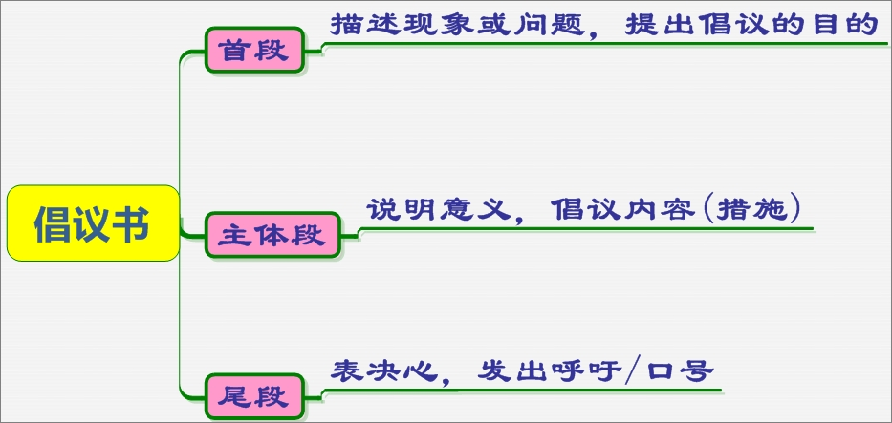
写倡议书要注意： 一、所倡议的事情必须有一定的社会意义；
- 能够引起有关方面的人士的关注；
三、所倡议的事情要切实可行，能够让人们附议。
第一步，说明为什么要发出倡议，即发出倡议的背景和目的；
第二步，说清楚倡议什么事情，即倡议的具体内容及所倡议事情的益处：
第三步，表明倡议者的决心和希望。
第一部分：开篇点题，交代清楚背景和原因，引出倡议的目的；
第二部分：列举倡议的具体内容或要求；
第三部分：再次强调，引出呼吁。
必识核心词汇
1. litter (v. /n.) 乱扔垃圾
2. habitat (n.) 栖息地
3. threaten (v.) 威胁
4. survival (n.) 生存
5. clean-up (n.) 清理活动
6. bird feeder 鸟类喂食器
7. cooperate (v.) 合作
8. take action 采取行动
9. call on sb. to do sth. 号召某人做某事
10. rise to the challenge 迎接挑战
11. make an effort to do sth. 努力做某事
12. benefit from 从……受益
必记高级句式
【满分句型模板之开篇“凤头”句】
1. I'm calling on your active participation in ...
2. Recently, it has become an increasingly serious problem to see...
3. In recent years, the problem on .... has become a heated topic.
4. Hence, safeguarding the ... is not optional; it is a necessity for our survival and future generations.
5. With the approaching of..., I'd like to call for everyone to...
6. Unfortunately, they face a variety of dangers, many of which are in urgent need of protection.
7. So their protection is at the top of the agenda for the benefit of all mankind.
【满分句型模板之中间“猪肚”句】
1. To safeguard ......, we must take immediate action. This includes......
2. As students, it is strongly advisable for you to be volunteers in some organizations, where you can launch campaigns and give out leaflets to raise people's awareness of the preservation.
3. With the aim of…, we are supposed to carry out a series of ...measures. For one thing, ... For another, ...
4. In my opinion, we should spare no effort to ...
5. Effective measures should be adopted before things get worse.
6. Only if we take effective measures to deal with this problem now, can we...
【满分句型模板之结尾“豹尾”句】
1. It's high time that we took / should take measures to change the situation.
2. Let's join our hands and take action immediately.
3. Let's take action now! I'm convinced our efforts will eventually pay off.
4. Every effort counts/makes a difference/matters. Let's work together to make the world a better place.
必备满分模板
【满分作文模板1】
Dear Sir/Madam,
I am ______, __________________(身份). I am writing this letter to call on ____________(写信目的). Nowadays, ______________ (描述现状分析). It is necessary for us to __________________(做某事).
With the aim of _________(目的),________________________(措施). First of all，_______________________. In addition，___________________. Last but not least，_________________.(具体采取的行动).
All in all, it is high time that _______________(做某事). __________(意义). Let's take action now!
Yours,
XXX
【满分作文模板2】
Dear Sir/Madam,
You must have noticed that _______ (野生动物现状，如 “many wild animals are losing their homes”). I am writing to call on all of us to work together to protect them.
The problems they face are serious: _______ (列举 1-2 个问题，如 “illegal hunting and habitat loss”). These issues not only harm animals but also threaten our ecosystem.
To change this, we can take the following steps:First, _______ (倡议 1) because _______ (理由).
Second, _______ (倡议 2) which will _______ (效果).
Let's start now. I hope our actions can make a difference.
Best wishes,
XXX
模板03 演讲/发言稿
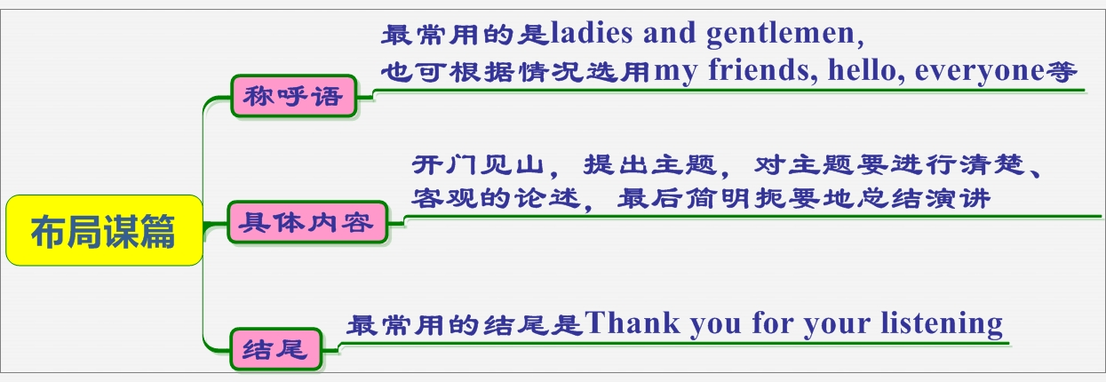
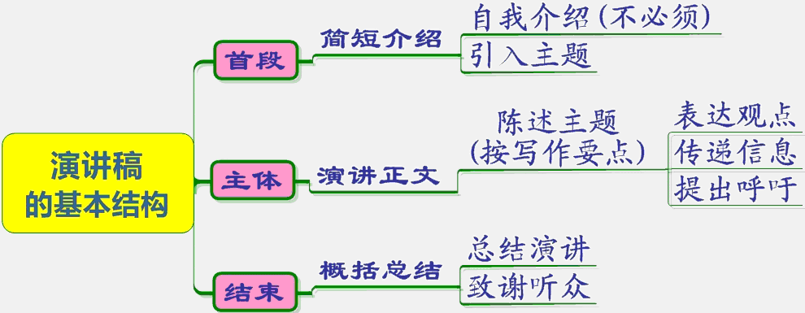
必识核心词汇
1. rise to the challenges迎接挑战
2. acquire knowledge掌握知识
3. enjoy personal growth享受个人成长
4. make medical advances实现医学突破
5. make the most of school resources充分利用学校资源
6. take an active part in different sports积极参与各种体育活动
7. develop a positive attitude培养积极的心态
8. set clear goals设立清晰的目标
9. balance schoolwork with other activities平衡课业与其它活动
10. make efforts to improve problem-solving skills努力提升解决问题的技能
11. grow into a well-rounded individual 成长为全面发展的个人
12. Time flies.--时光飞逝。
13. Time is money.--时间就是金钱。
14. Time waits for no man.--时不我待。
15. Make hay while the sun shines.--趁热打铁。
16. A friend in need is a friend indeed.--患难见真情。
17. No pain, no gain.--不劳无获。
18. Live and learn.--活到老，学到老。
19. Knowledge is power.--知识就是力量。
20. Learn not and know not.--不学则不知。
21. Seize the day. 只争朝夕。
必记高级句式
【满分句型模板之开篇“凤头”句】
1. Ladies and gentlemen/Boys and girls, I’m greatly honored to speak here to talk about...on behalf of....
女士们、先生们/男孩们、女孩们，我非常荣幸能在这里谈论……我代表....
2. Thank you for giving me the opportunity to make a speech about...
感谢大家给我这个机会就……
3. It’s my honor to stand here and talk something about...
我很荣幸站在这里谈谈……
4. It’s my great honor to have the opportunity to share with you my opinion on how to take online courses more effectively.
我很荣幸有机会与大家分享我对如何更有效地学习网络课程的看法。
5. Ladies and gentlemen, today I’d like to deliver a lecture on stressing the importance of having a positive attitude to study.
女士们，先生们，今天我想做一个讲座，强调有一个积极的学习态度的重要性。
6. It’s my great honor to stand here on behalf of all the students, and I’d like to offer you my warmest welcome.
我很荣幸能代表全体学生站在这里，我想向你们表示最热烈的欢迎。
【满分句型模板之中间“猪肚”句】
1. I think it important / difficult / necessary / likely...to do sth.
我认为重要的/困难的/必要的/可能的……做某事
2. Local transportation is easily accessible / of easy access / very convenient; =People can have easy access to local transportation.
当地的交通很容易到达/很方便;人们可以很容易地获得当地的交通工具。
3. Above all / Most important of all, you should have faith in yourself.
最重要的是，你应该对自己有信心。
4. With the sharp growth of..., ...... have / has become increasingly important in our daily life.
随着……的急剧增长。在我们的日常生活中......已经变得越来越重要。
5. When it comes to the most important family tradition, the first that comes to my mind is honesty.
说到最重要的家庭传统，我首先想到的是诚实。
6. In my view, important though it is for students to have better performance in exams, health is of equal significance.
在我看来，虽然学生在考试中有更好的表现很重要，但健康也同样重要。
7. No one can deny the fact that / It can be said with certainty that / There’s no denying that / There’s no doubt that / Undoubtedly, the environment pollution is getting increasingly serious.
没有人能否认这一事实/可以肯定地说/不可否认/毫无疑问，环境污染正变得越来越严重。
【满分句型模板之结尾“豹尾”句】
1. Thank you from the bottom of my heart for giving me this chance to speak to you today.
我从心底感谢你们今天给我这个机会在这里讲话。
2. I hope everyone finds your stay here an enjoyable experience and your visit will surely promote our friendship.
我希望你们在这里过得愉快，你们的来访一定会增进我们的友谊。
3. That’s all I want to say about this point. Thank you.
这就是我想说的。谢谢你！
4. That’s all. Thank you for your listening / attention.
这是所有。谢谢你的聆听。
必备满分模板
【满分作文模板1】
Boys and girls/Ladies and gentlemen,It's a great honor for me to stand here and give my speech._________(表示荣幸)The topic of my speech is ___________.(提出演讲主题)
To begin with, many people suggest that ___________.(话题或现象列举)Secondly, ___________. Thirdly, ___________ .What I want to stress is that ___________.(重申主题)For one thing, . For another, . Besides, ___________.(原因或重要性列举)In a word, ___________.(总结)
Thank you for your listening/attention.
XXX


类型01 建议信
链接高考
(2025·新课标I卷)假定你是李华，你班的英语报要增设一个栏目。外教 Jenny 提出“Fun at my school”和“Guess who I am”两个选项供大家选择。请给Jenny写一封邮件，内容包括：
(1)你的选择；
(2)说明理由。
注意：
(1)写作词数应为80个左右；
(2)请按如下格式在答题卡的相应位置作答。
Dear Jenny,
I really like the idea of adding a new column to our English newspaper.
____________________________________________________________________________________________________________________________________________________________________________________________________________________________________________________________________________________________________________________________________________________________________________________________________________________________________________________________________________
Yours,
思维解析
【写作思路】
本篇书面表达属于应用文。要求考生就外教Jenny提出的校英文报增设一个栏目，在“Fun at my school”和“Guess who I am”两个选项中给出自己的推荐，并说明理由。
【参考范文】
Dear Jenny,
I really like the idea of adding a new column to our English newspaper. I’m writing to express that my predilection goes to “Guess who I am”, which capitalizes on an object clause to signal its potential contents.
The column will serve as a catalyst for closer bonds between students. Redoubling efforts to boost academic performance, we pay little heed to other classmates’ personalities, hobbies, strengths, and even aspirations. Such an inviting column, adopting a “description and guess” approach, must expose everyone to others’ characteristics, thus strengthening mutual understanding. More importantly, more friendships will be forged, since the column enables us to befriend someone on the same wavelength.
This eye-catching column, I’m firmly convinced, won’t fail to grant the whole class a harmonious atmosphere.
Yours,
Li Hua

变式应用
1.假定你是李华，你的笔友Chris来信说，他想使用AI生成的作文交作业。请你给他回信，表达你的看法。要点包括：
1. 表达态度；
2. 阐述理由；
3. 提出建议。
注意：
1. 写作词数应为80左右；
2. 请按如下格式在答题纸的相应位置作答。
Dear Chris,
____________________________________________________________________________________________________________________________________________________________________________________________________________________________________________________________________________________________________________________________________________________________________________________________________________________________________________________________________________
Sincerely,
Li Hu
【写作思路】本篇书面表达属于应用文。要求考生给笔友Chris回信，说明对于他想使用AI生成的作文交作业的态度、 阐述理由以及提出建议。
【参考范文】
Dear Chris,
I really don’t think using AI-generated essays for homework is a good idea.
Homework is designed to help you practice writing skills and form your own thoughts. Relying on AI means you’ll miss the chance to think deeply, and it’s not honest to your teacher. Over time, it might even make you lose confidence in your own abilities.
Why not try writing a draft first? If you’re stuck, I can give you suggestions. True progress comes from your own efforts — AI can’t replace that.
Sincerely,
Li Hua
2. 许多青少年由于学业压力和社会期望感到焦虑。你认为这些压力的原因是什么?应该如何解决?
写作要点：(1)分析青少年承受压力的原因。(2)提出解决这些压力的建议。
注意：(1)写作词数应为80左右；(2)请按如下格式在答题纸的相应位置作答。
____________________________________________________________________________________________________________________________________________________________________________________________________________________________________________________________________________________________________________________________________________________________________________________________________________________________________________________________________________
【写作思路】本篇书面表达属于应用文。要求考生写一篇文章分析青少年承受压力的原因并提出解决这些压力的建议。
【参考范文】
Nowadays, many teenagers suffer from anxiety due to academic pressure and social expectations.
There are several reasons for this. First, students have to spend long hours studying to get good grades, which leaves them little time for rest or hobbies. Second, parents and teachers often expect them to succeed, making them feel guilty if they don’t perform well. Third, teenagers may also pressure themselves to be perfect, fearing failure.
To solve these problems, schools should reduce homework and offer more mental health support. Parents should encourage their children instead of pushing them too hard. Society should also create a more relaxed environment for young people.
In short, reducing pressure and providing support can help teenagers grow up happily and healthily.

类型02 倡议书
链接高考(2022年全国甲卷)你校将以六月八日世界海洋日为主题，举办英语征文比赛。请你写一篇短文投稿，内容包括:
1.海洋的重要性;
2.保护海洋的倡议。
注意:
1.词数100左右;
2.题目和首句已为你写好。
Our Oceans. Our Responsibility
June 8th was officially named by the UN in 2009 as World Oceans Day
________________________________________________________________________________________________________________________________________________________________________________________________________________________________________________________________________________________________________________________________________________________________________________________________________________________________________________________________________________________________________________________________________________________________________
思维解析
【写作思路】本篇书面表达为一篇应用文。要求学生以世界海洋日为主题，写一篇短文投稿。其内容包括：海洋的重要性和保护海洋的倡议。
【参考范文】
Our Oceans, Our Responsibility
June 8th was officially named by the UN in 2009 as World Oceans Day. It was set up to raise awareness of protecting the oceans, which play a crucial part in global ecosystem. Without the oceans, no living things would survive, humans included.
As senior students, we can protect oceans in our own way. First, try every means to fight against global warming, which has become a great threat to sea creatures. Second, when surfing or boating, never drop litter into the sea. In addition, take an active part in the voluntary activities launched by the ocean organization.
Every little effort counts. As long as we try our best, we will make a difference to the marine environment.

Our Oceans, Our Responsibility
June 8th was officially named by the UN in 2009 as World Oceans Day. Oceans are vital to our planet: they produce over half of the oxygen we breathe, support countless marine species, and regulate the global climate. Without healthy oceans, life on Earth would struggle to survive.
However, our oceans face severe threats—plastic pollution chokes marine life, overfishing disrupts ecosystems, and oil spills poison waters. It’s time to act.
Let’s start with small steps: reduce single-use plastics, participate in coastal clean-ups, and support sustainable seafood. By spreading awareness, we can urge more people to protect our blue planet.
Oceans connect us all. Protecting them is not just a duty, but a promise to future generations.

变式应用
1.(2025·江西九江·二模)假设你是李华，你校英语报编辑就最近开展的“运动助力健康”主题活动特邀你写一篇倡议书鼓励学生积极参加体育运动。内容包括：
(1)举例说明体育运动的益处；
(2)呼吁积极参与。
注意：
(1)写作词数应为80个左右；
(2)请按如下格式在答题纸的相应位置作答。
Dear fellow students,
____________________________________________________________________________________________________________________________________________________________________________________________________________________________________________________________________________________________________________________________________________________________________________________________________________________________________________________________________________
【写作思路】本篇书面表达属于应用文写作中的倡议书。要求考生以“运动助力健康”为主题一篇倡议书，鼓励学生积极参加体育运动。
【参考范文】Dear fellow students,
As the saying goes, “All work and no play makes Jack a dull boy.” Sports play a significant role in our daily lives, bringing us numerous benefits.
First and foremost, regular exercise, like jogging, strengthens our hearts and lungs, and builds muscle and bone strength. Moreover, sports also relieve stress. Whether playing basketball with friends or practicing yoga alone, we can relax and stay positive. Most importantly, sports teach us perseverance and teamwork, helping us grow.
In conclusion, sports are an essential part of our lives. Let’s actively participate in sports and embrace a healthier and more fulfilling life.

2.(2025·辽宁·模拟预测)假定你是李华，请向刚来你校的国际交换生发一篇倡议书，鼓励他们与各国同学相互建立良好的人际关系，内容包括：
1.说明重要性；
2.提出具体做法；
3.表达期许和希望。
注意：
1.写作词数应为80左右：
2.开头和结尾已为你写好，不计入总词数。
Dear International Exchange Students.
I’m Li Hua, a student from your host school.
_____________________________________________________________________________________________________________________________________________________________________________________________________________________________________________________________________________________________________________________________________________________________________________________________________________________________________________________________________
Best regards.
Li Hua
【写作思路】
本篇书面表达属于应用文。要求考生向刚来你校的国际交换生发一篇倡议书，鼓励他们与各国同学相互建立良好的人际关系。
【参考范文】
Dear International Exchange Students,
I am Li Hua, a student from your host school. I would like to extend a warm welcome to you all and take this opportunity to encourage you to build positive interpersonal relationships with both local and international peers.
Establishing good relationships is crucial for a harmonious and enriching academic experience. It fosters a supportive learning environment and broadens our cultural horizons.
To achieve this, we’d better engage in open communication, participate in group activities, and show respect for each other’s cultures and viewpoints.
I hope we can all make lasting friendships and create a welcoming atmosphere for everyone.
Best regards,
Li Hua

类型03 演讲/发言稿
- 链接高考
(2025浙江1月首考)你将参加英语课上的“一分钟演讲”活动。请你针对部分同学在校园内用手机拍摄短视频的现象写一篇演讲稿，内容包括：
(1)陈述看法；
(2)提出建议。
注意：
(1) 写作词数应为80左右；
(2) 请按如下格式在答题纸的相应位置作答。
My Views on Filming Short Videos on Campus
___________________________________________________________________________________________________________________________________________________________________________________________________________________________________________________________________________________________________________________________________________________________________________________________________________________________________________________________________
【写作思路】本篇书面表达属于演讲稿。要求考生针对部分同学在校园内用手机拍摄短视频的现象陈述看法并提出建议。
【参考范文】
My Views on Filming Short Videos on Campus
Dear classmates,it’s my great honor to make a speech on the phenomenon that some of us have been filming short videos on campus.
In my opinion, it can be a fun way to record campus life, but it also has its drawbacks. Not only may it distract us from our studies and even disrupt the school order, but it might also cause unnecessary comparisons and affect our self-esteem when the videos don’t get the expected response.
I suggest we should limit the time for filming and choose proper places. Let’s focus more on our academic tasks and make good use of our time on campus.
Thank you!
变式应用
假定你是李华，你校英语社即将开展一次题为“Is AI-painting Considered Art? ”的辩论赛。请你写一份参赛发言稿，内容包括：
1. 表达观点；
2. 陈述理由。
注意：
1. 写作词数应为80个左右；
2. 请按如下格式在答题卡的相应位置作答。
Hi, everyone! I’m Li Hua from Class 3.
____________________________________________________________________________________________________________________________________________________________________________________________________________________________________________________________________________________________________________________________________________________________________________________________________________________________________________________________________________
【写作思路】本篇书面表达属于应用文。要求考生以李华身份，为英语社“AI绘画是否被视为艺术?”辩论赛撰写参赛发言稿，表达观点并陈述理由。
【参考范文】
Hi, everyone! I am Li Hua from Class 3. I firmly believe that AI-generated paintings should be recognized as a new form of art, which is simply the next step in the creative evolution.
As is widely acknowledged, art has always developed with technology, from oil paints to digital tools. With the various applications of AI technology, paintings are able to demonstrate more remarkable creativity than ever before. By analyzing thousands of artworks, AI produces original pieces that can stir up deep emotions, just like human-created art does. Many galleries now exhibit AI artworks, proving its artistic value.
In brief, AI painting can be considered as art, allowing people to explore greater potential.
2. 假定你是李华，你的作品在校英语俱乐部举办的“Best Festival Moment”短视频比赛中获一等奖。现俱乐部邀请你分享这次经历，请你写一份演讲稿，内容包括：
1. 你的创作；
2. 你的感想。
注意：
1. 开头已给出；
2. 写作词数应为80左右；
3. 请按如下格式在答题卡的相应位置作答。
Hello, everyone. I’m Li Hua.
____________________________________________________________________________________________________________________________________________________________________________________________________________________________________________________________________________________________________________________________________________________________________________________________________________________________________________________________________________
【写作思路】本篇书面表达属于演讲稿。要求考生以李华的身份，在英语俱乐部分享自己作品在“Best Festival Moment”短视频比赛中获一等奖的经历，需包含创作内容和个人感想。
【参考范文】
Hello, everyone. I’m Li Hua.
I’m honored to share my experience of winning the first prize in the “Best Festival Moment” video competition. In my video, I showed the Spring Festival reunion dinner at my grandparents’ house, which truly captured the essence of the festival. The warm atmosphere and the smiles on everyone’s faces truly captured the essence of the festival.
This experience has been really rewarding as it made me cherish family more and understand the beauty of traditional festivals. Thanks to the English club for this great opportunity!


巩固提升
1.【科技主题】(2025·四川成都·一模)对随着人工智能的普及，越来越多的同学使用人工智能完成作业，由此产生了一些不良影响。假定你是校学生会主席李华，请代表学生会写一封英文倡议书，呼吁同学们合理使用人工智能，内容包括：
1.描述现象
2.发出倡议
注意：
1.写作词数为80左右；
2.请按如下格式在答题卡的相应位置作答。
__________________________________________________________________________________________________________________________________________________________________________________________________________________________________________________________________________________________________________________________________________________________________________________________________________________________________________________________________
【写作思路】本篇书面表达属于应用文。要求考生代表学生会写一封英文倡议书，呼吁同学们合理使用人工智能。
【参考范文】
Dear fellow students,
With AI becoming increasingly accessible, many now rely on it to complete assignments. While this technology offers convenience, overuse may hinder creativity and independent thinking. Some homework even shows identical AI-generated content, which weakens academic integrity.
Therefore, we propose: First, use AI as a learning aid rather than a shortcut. Analyze its suggestions critically instead of copying blindly. Second, prioritize original ideas. Complete core tasks independently before seeking AI assistance. Let’s embrace technology wisely while preserving our intellectual growth.
The Students’ Union
Li Hua

2.【新考向】(2025·湖南·一模)在英语课堂小组讨论的环节，英语老师让大家就高中生用AI写作文的现象发言，请你作为小组代表，撰写一篇发言稿汇报讨论成果，内容包括：
1.发表看法：
2.提出建议。
注意：
1.写作词数应为80个左右；
2.请按如下格式在答题卡的相应位置作答。
Opinion on High School Students’ Using AI to Write Essays
Hello, everyone!
____________________________________________________________________________________________________________________________________________________________________________________________________________________________________________________________________________________________________________________________________________________________________________________________________________________________________________________________________________
【写作思路】本篇书面表达属于应用文。要求考生作为小组代表，就高中生用AI写作文的现象发表看法并提出建议。
【参考范文】
Opinion on High School Students’ Using AI to Write Essays
Hello, everyone!
Our group believes that using AI to write essays has both advantages and disadvantages.
While it can provide quick ideas, over-reliance may hinder students’ thinking skills. What matters most is learning to express ideas independently. We suggest that students use AI as a tool for inspiration, not answers. Teachers should also set clear rules, like requiring students to explain their essays afterward. This ensures that AI helps rather than replaces learning.
In conclusion, we think that AI can be useful if used wisely. What counts is maintaining the balance between technology and self-improvement.
Thank you!

3.【新素养】(2025·江西萍乡·一模)假定你是学生会主席李华，国际志愿者日(International Volunteer Day)将要到来，请以学生会的名义向全校师生写一封倡议信，号召同学们参加“互助，互爱”的志愿宣传活动，内容包括：
1. 倡议目的；
2. 活动内容；
3. 呼吁参加。
提示词：互助互爱 mutual assistance and care
注意：
1. 写作词数应为80个左右；
2. 请按如下格式在答题卡的相应位置作答。
______________________________________________________________________________________________________________________________________________________________________________________________________________________________________________________________________________
【写作思路】本篇书面表达属于应用文。要求考生以学生会的名义写一封倡议信，号召同学们参加“互助，互爱”的志愿宣传活动。
【参考范文】Distinguished teachers and schoolmates,
In a bid to embrace the International Volunteer Day, I on behalf of the Student Union, appeal to all the teachers and students to actively engage in the volunteer campaign with the theme of “mutual assistance and care”.
The event, which falls on December 5th, will kick off with a visit to the nursing home in our community, where we will engage in cleaning activities for the elderly and share our joy with them. Following that, we will conduct a beach clean-up, providing us with the opportunity to participate in garbage sorting at the coastal tourist spots. Finally, the highlight of the activity will involve fundraising for a charity program, bringing the event to a meaningful conclusion.
Rose given, fragrance in hand. Don’t hesitate anymore and jump at the chance to make a brighter world!
The Student Union
4.【跨文化交流】假设你是李津。你所在的城市将于9月28日，即孔子(Confucius)诞辰之日定为“汉字书写日”。请你根据以下要点写一封倡议书，发布在校园网上。
1. 设立“汉字书写日”的意义(写汉字的机会减少，人们提笔忘字，字迹潦草……)：
2. 汉字具有悠久的历史，书法是一项传统的艺术，应被传承和保护：
3. 发出倡议。
注意：
1. 词数不少于80：
2. 可适当加入细节，使内容充实，行文连贯。
试题词汇：汉字书写日 Chinese Character Writing Day 书法 calligraphy
Dear fellow students,
____________________________________________________________________________________________________________________________________________________________________________________________________________________________________________________________________________________________________________________________________________________________________________________________________________________________________________________________________________
【写作思路】本篇书面表达属于应用文。要求考生对于你所在的城市将于9月28日，即孔子(Confucius)诞辰之日定为“汉字书写日”这一情况，根据所给要点写一封倡议书，发布在校园网上。
【参考范文】
Dear fellow students,
Our city will set September 28th, the birthday of Confucius, as Chinese Character Writing Day.
Nowadays, due to the wide use of digital devices, we seldom write by hand. As a result, many people often forget how to write characters and their handwriting becomes poor.
As is known, Chinese characters, with a long history, play a significant role in our culture. Moreover, calligraphy, a traditional art of writing Chinese characters, is part of our precious cultural heritage.
Thus, let’s take this opportunity to write more, and we can start by writing neatly in our daily homework. Let’s work together to promote the beauty of Chinese characters.
Li Jin

冲刺突破
1. (2025·河北·一模)假定你是国际学校学生李华，你发现学校图书馆的书籍更新缓慢，且线上查询系统(online search system)时常出现故障。请给校长写一封信，说明问题并提出改进措施。
注意：
(1)词数80左右；
(2)请按如下格式在答题卡的相应位置作答。
Dear Principal Smith,
____________________________________________________________________________________________________________________________________________________________________________________________________________________________________________________________________________________________________________________________________________________________________________________________________________________________________________________________________________
Yours,
Li Hua
【写作思路】本篇书面表达属于应用文。要求考生给校长写一封信，书面学校图书馆的书籍更新缓慢，且线上查询系统时常出现故障的问题，并提出改进措施。
【参考范文】
Dear Principal Smith,
I am Li Hua, a senior student from our school. I am writing to address some concerns regarding our school library. Recently, many students have noticed that the book collection is outdated, with limited new arrivals, which affects our studies and reading interests. Additionally, the online search system often fails to work correctly, making it difficult to locate books efficiently.
To improve the situation, I kindly suggest two measures. First, the library could set aside more funds to purchase popular and academic books regularly. Organizing book donation drives among students might also help. Second, upgrading the online system or providing professional IT support would ensure smoother searches.
Thank you for considering these suggestions. I believe these changes will greatly benefit our learning environment.
Yours,
Li Hua
2. 你校将要举行一次主题为“How to Communicate with Our Parents”的英语演讲比赛，请你写一篇演讲稿。内容包括：
1. 尊重并信任父母；2. 常与父母聊天；3. 换位思考问题。
注意：
1. 写作词数应为100个左右；
2. 请按如下格式作答。
参考词汇：换位思考问题 put oneself in sb.’s shoes
How to Communicate with Our Parents
Hello, everyone. I’d like to share some thoughts on communicating with our parents.
____________________________________________________________________________________________________________________________________________________________________________________________________________________________________________________________________________________________________________________________________________________________________________________________________________________________________________________________________________________________________________________________________________________________________________________________________________________________________________________________________________________________________________________________________________________________________________________________________________________________________________________________
Thank you for your listening.
【写作思路】本篇书面表达属于应用文。要求考生围绕“How to Communicate with Our Parents”这一主题撰写演讲稿，分享与父母沟通的方法，包括尊重信任父母、常与父母聊天、换位思考问题。
【参考范文】
How to Communicate with Our Parents
Hello, everyone. I’d like to share some thoughts on communicating with our parents.
Parents are the people who love us most, so it’s necessary to keep a good relationship with them. Here are my ideas on how to make it easier to communicate with parents.
First, we should respect and trust our parents. Don’t be rude to them even if they have done something wrong. They have experienced more and always try their best to protect us from dangers. Second, if we often talk with them about our life and experiences, we will know each other better. What’s more, we can often tell our parents how much we love them. If sometimes we don’t agree with our parents’ decisions, we should try to put ourselves in their shoes and we will soon understand them. Remember that what they really want is only the best for us.
Thank you for listening.
3.(2025·山东聊城·一模)假定你是校学生会主席李华，你校拟举办主题为“让世界看见中国”(Show China to the World)的小红书(RedNote)视频拍摄活动。请写一篇倡议书，发表在校英文报上，内容包括：
1.倡议内容；
2.提出倡议。
注意：
1.写作词数应为80左右；
2.请按如下格式在答题卡的相应位置作答。
Dear fellow students,
____________________________________________________________________________________________________________________________________________________________________________________________________________________________________________________________________________________________________________________________________________________________________________________________________________________________________________________________________________
Li Hua
President of the Student Union
【写作思路】本篇书面表达属于应用文写作中的倡议书。要求考生写一篇倡议书，发表在校英文报上，倡议同学们参加以“让世界看见中国”为主题的小红书视频拍摄活动。
【参考范文】Dear fellow students,
As RedNote gains popularity in the U.S., it has become a vital platform to share authentic Chinese stories globally. To bridge cultural gaps and showcase China’s colourful diversity, the Student Union calls on everyone to join in our video campaign titled “Show China to the World”.
By uploading creative videos on RedNote, we can present a true, beautiful China — its traditions, innovations, and daily life — while boosting cross-cultural understanding. As the younger generation, it’s our duty to spread China’s voice. The videos are supposed to be authentic, positive, and under 3 minutes with the themes of our festivals, cuisine, school activities, etc.
Post your videos on RedNote. Take action now. Let your creativity shine!
Li Hua
President of the Student Union

