**考点串讲03 由关系代词、关系副词引导的限制性定语从句（精讲精练）**

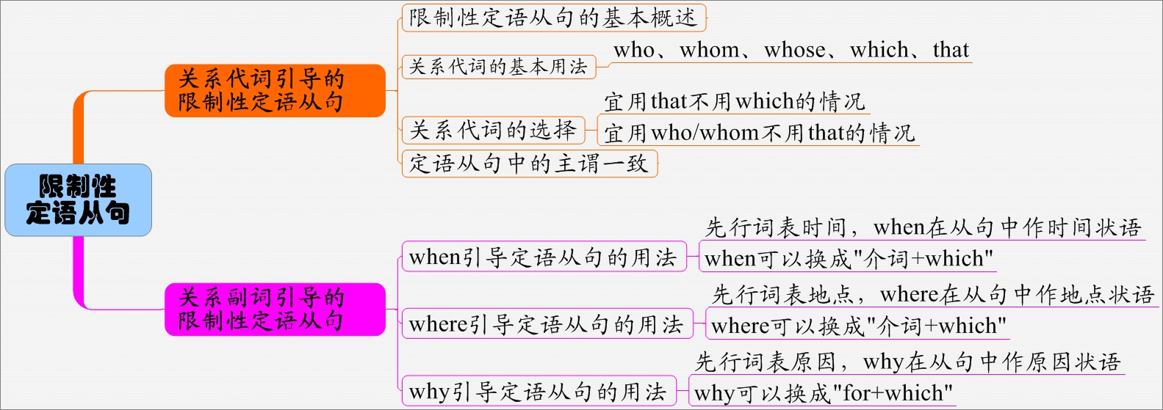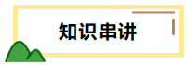

**定语从句概述**

|  |  |  |  |
| --- | --- | --- | --- |
| 定  语  从  句 | 定义 | 在主从复合句中, 对某一名词、代词或名词短语起修饰、限制作用的从句 | |
| 关  系  词 | 关系代词 | who; whom; whose; which; that |
| 关系副词 | when; where; why |
| 可分为限制性定语从句和非限制性定语从句 | | |
| 本单元主要学习关系代词who, whom, that, which, whose引导的限制性定语从句 | | |

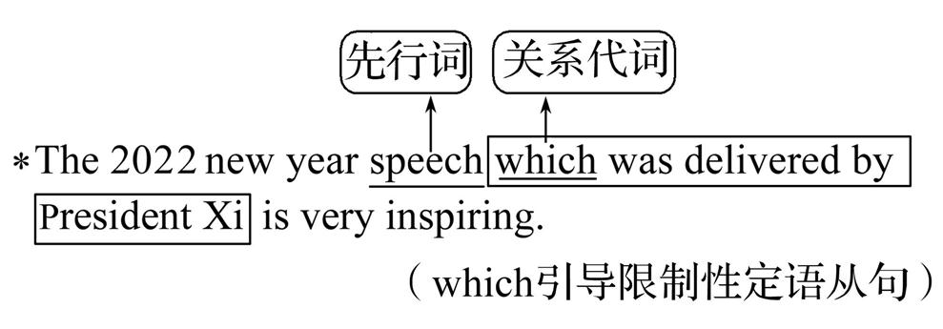

习主席所做的2022新年致辞非常鼓舞人心。

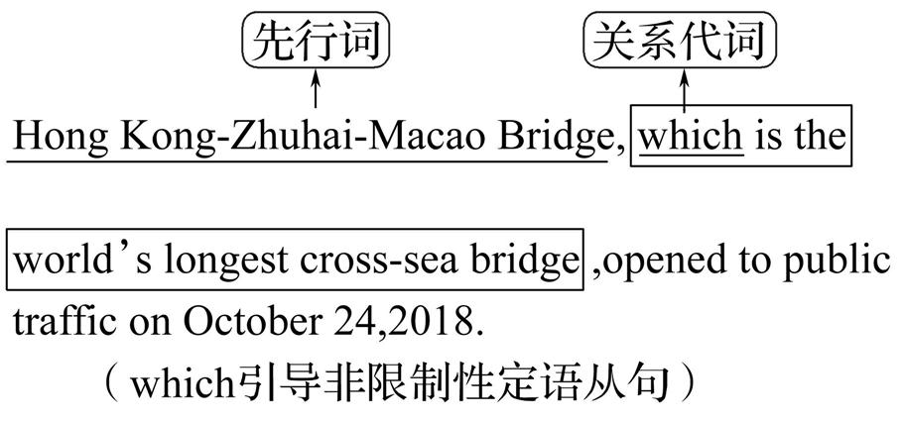

世界上最长的跨海大桥——港珠澳大桥, 在2018年10月24日向公众交通开放。

**限制性定语从句**

限制性定语从句指修饰名词、代词或名词短语的从句，对所修饰的对象加以限制，表示”……的(人)”或”……的(物)”。从句不可去掉，一旦去掉主句的意思则不完整。被修饰的名词、代词或名词短语称为先行词。引导定语从句的词被称为关系词.

【名师点津】 关系词的3个作用

关系词通常有下列三个作用: (1)引导定语从句; (2)代替先行词; (3)在定语从句中充当一个成分。

1. **关系代词引导的限制性定语从句**

1.关系代词

|  |  |  |
| --- | --- | --- |
| 关系代词 | 指代  (即先行词) | 在定语从句中所作的句子成分 |
| who | 人 | 主语、宾语 |
| whom | 人 | 宾语 |
| which | 物 | 主语、宾语 |
| that | 人/物 | 主语、宾语、表语 |
| whose | 人/物 | 定语 |

①The 80, 000 objects collected by Sir Hans Sloane, for example, formed the core collection of the British Museum **which**/ **that** opened in 1759.

例如, 汉斯·斯隆爵士收藏的8万件物品构成了在1759年开放的大英博物馆的核心馆藏。

②Any man **that**/**who** has a sense of duty will be concerned about this item.

任何有责任感的人都会关注这个项目。

③The rescue worker (**whom/that/who**) you are waiting for has come.

你正在等的救援人员已经来了。

④Mary is fond of music **that**/**which** is quiet and gentle.

玛丽喜欢安静轻柔的音乐。

⑤The party **that**/**which** was organized by Tom was held outdoors at dusk.

由汤姆组织的这个聚会傍晚时在户外举行。

⑥I frequently visit a scientist **whose** name is known all over the country.

我经常拜访一位全国知名的科学家。

**特别提醒:**

**关系代词只用that而不用which的情况**

1. 当先行词为all, everything, nothing, anything, little, much等不定代词或先行词被这些词修饰时。

**All** **that** you must keep in mind is that you must be buried in your research. 你必须记住的所有的事情是你必须专心于你的研究。

2. 当先行词是序数词、形容词最高级或先行词被序数词或形容词最高级修饰时。

He was **the first survivor that** was dug out from the ruins.

他是从废墟中被挖出的第一个幸存者。

3. 当先行词被the only, the very, the last修饰时。

**The only thing that** we can do is give in to our parents’ ideas.

我们唯一能做的事情就是听从我们父母的意见。

4. 当先行词既指人又指物时。

I can remember well **the persons and some pictures that** I saw in the room. 我能清楚地记得我在那个房间见到的人和一些照片。

5. 当主句是以who或which开头的疑问句时, 为避免重复而用that。

Who is **the man that** came to rescue you in this **disaster**? 在这次灾难中救你的人是谁?

6. 当先行词在定语从句中作表语时。

Shanghai is no longer **the city that** it used to be.

上海不再是过去的那座城市了。

**二.关系副词引导的限制性定语从句**

关系副词在引导定语从句时, 其功能相当于介词短语, 在从句中作状语。引导定语从句的关系副词有when、where、why。

|  |  |  |
| --- | --- | --- |
| 关系副词 | 先行词 | 功能 |
| when | 表时间的名词 | 时间状语 |
| where | 表地点的名词 | 地点状语 |
| why | 表原因的名词 | 原因状语 |

**1. 关系副词when引导的定语从句**

关系副词when引导定语从句时, 先行词应是表示时间的名词, 如time, day, hour, year等。关系副词在从句中作时间状语。

But like all performances, there are moments **when** things go wrong.

但就像所有的表演一样, 总有出错的时候。

We have entered into an age **when** dreams have the best chance of coming true.

我们已经进入了一个时代, 在这个时代梦想实现的机会最大。

**特别提醒**

**when/which/that**引导定语从句表时间

when是关系副词, 在从句中只能作时间状语, 而不能作宾语或主语。关系词如果在从句中作主语或宾语要用关系代词which或that。

①Do you remember the days **when** we chatted with each other all night?

你还记得我们整夜聊天的那些日子吗? (when在从句中作状语)

②Do you remember the days **that/which** we spent together on the farm?

你还记得我们在农场一起度过的那些日子吗? (that或which作spent的宾语)

**2. 关系副词where引导的定语从句**

关系副词where引导定语从句时, 先行词应是表示地点的名词, 如place, factory, house, village等或表示抽象地点的名词point, situation, condition, stage, case等。关系副词在从句中作地点状语。

There are two parks less than 10 minutes’ walk from home **where** neighbourhood children gather to play.

从家里步行不到10分钟的地方有两个公园, 附近的孩子们聚集在那里玩耍。

Self-driving is an area **where** China and the rest of the world are on the same starting line.

自动驾驶是中国和世界上其他国家都处于相同起跑线的一个领域。

Their child is at the stage **where** she can say individual words but not full sentences. 他们的孩子正处于这样的阶段, 她只会说单个的词不会说完整的句子。

**特别提醒**

**where/which/that**引导定语从句表地点

若表示地点的先行词在从句中作地点状语, 用where来引导定语从句; 若作主语或宾语, 应用which或that来引导定语从句。

This is the house **which/that** was built by my grandfather forty years ago.

这是我爷爷在40年前建造的房子。(定语从句中缺少主语, 所以用which/that, 不用where)

The school **which/that** we visited yesterday is newly built. 我们昨天参观的那所学校是新建的。(关系代词which/that在从句中作宾语)

**3. 关系副词why引导的定语从句**

关系副词why引导定语从句时, 先行词常常为reason, 关系副词在从句中作原因状语。

I don’t know the reason **why** he didn’t turn to his good friend for help yesterday.

我不知道昨天他为什么没向他的好朋友求助。

The reason **why** he didn’t come to the party is that he didn’t want to see Jane.

他不来参加聚会的原因是他不想见到简。

**特别提醒**

**why/which/that**引导定语从句表原因

若先行词reason在从句中作原因状语, 用why来引导定语从句; 若其在从句中作主语或宾语, 应用that或which来引导定语从句。

①I won’t listen to the reason **that/which** you have given us. 我不会听你给我们的理由。

②What you really need to do is figure out the reason **why/for which** you fail the exam.

你真正需要做的是找出你考试失败的原因。

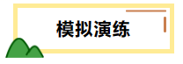

Ⅰ.单句语法填空

1．He still remembered the places and persons he visited there.

2．This is the very book has good maps showing details of world geography.

3．Tom worked on the most beautiful farm we visited the other day.

4．A true friendship carries a long history of experience determines who we are and keeps us connected.

5．Jordan’s skills were impressive, but the mental strength he showed made him unique.

6．The Boys and Girls Club he started in Chicago has been helping young people since 1996.

7．The team Lang Ping had built was falling apart.

8． Obviously, any child receives patient teaching over a long period is likely to improve.

9． The terrible shaking of the building woke up all the people were asleep.

10． For the consumers, it can save some time for the people don’t have much spare time .

11． Li Bai was a Chinese poet praised from his own day to the present as a romantic figure took traditional poetic forms to new heights.

12． The man with you shook hands just now is our English teacher.

13．Is this the man you talked about yesterday?

14． I got in touch with Michael I have been losing contact with for one year.

15． There are some athletes I want you to meet.

16． The children parents could not be found were looked after by neighbors and friends.

17． These students parents have come to China for business like the school very much.

18． At first sight I didn’t recognize the boy hair was dyed red.

19． His father works in a company name always appears in the local newspapers.

20． It is such a heavy rock no one can lift.

21． Judging from my own experience, I want to say a few words to those who have the same trouble I have.

22． We do the same work they do.

23． He is such a good boy everyone likes.

24．Yesterday I came across the man about you talked last time.

25．We want to buy a book of the theme is about biology.

26． Do you know the boy to I spoke just now?

27． It can be confusing to come across sentences in the same words have got different meanings.

28．It was Friday the speech was delivered in our school.

29． I will never forget those years I lived on the farm with the farmers, has a great effect on my life.

30． Tony will never forget these days she lived in China with her mother , has a great effect on her life .

31．I believe the time will soon come there will be no wars in the world.

32． I will never forget such a beautiful village I spent my childhood with my grandparents.

33．Mr. Fox said he liked the atmosphere everybody can have a free chat.

34． Let’s visit the Forbidden City, art collections are brought together in one impressive museum.

35.Do you think English is a language some phrases are confusing and difficult for beginners?

36．There are two main reasons I think it’s the best solution.

37． ---- Do you know the reason he was late for the meeting yesterday?

----Yes, but I don’t think the reason he told me is reasonable.

38． I don’t know the reason David has refused to see me .

39．I don’t know the reason you were absent from the meeting , but I’m sure that someone will tell me the reason you haven’t told me.

Ⅱ.句型转换

1． The reason why she was very sad was that her pet was killed in an accident. （仿写）

(Please give some advice to your friend who wants to lose weight.) (按要求仿写)

2．We found out the reason. Many young people don’t have enough sleep for this reason.

We found out the reason .

3．He does not identify happiness with money. That is the reason.(将两个句子合并为一个包含有定语从句的主从句)

4．The reason isn't believable. He didn't come to school for that. （用关系副词引导的定语从句合并句子）

→

5．Tom came late for the meeting because he was ill. (句型转换)

→Tom was ill. he came late for the meeting.

→Tom came late for the meeting. he was ill.

→ Tom came late for the meeting he was ill.

6． The reason is that I want to improve my spoken English. I want to apply for the position. (合并为定语从句)

7．Accidents often happen. The reason is that people don’t always obey the traffic rules. (用定语从句合为一句)

8．将下列两句话合并成含有关系副词的定语从句

Can you tell me the reason?

You were late for school for the reason.

9．I can’t figure out the reason. He left for the reason.(合并为定语从句)

I can’t figure out the reason he left .

10．①Climate change is the reason.②Many natural disasters happen for this reason. (合并为含定语从句的复合句)